OSSP-PRACTICAL-WEEK3
Task-1: Develop a C program using fork() that creates a parent and child process. Display the Process ID (PID), Parent Process ID (PPID), and process states at different stages of execution.
Source code:
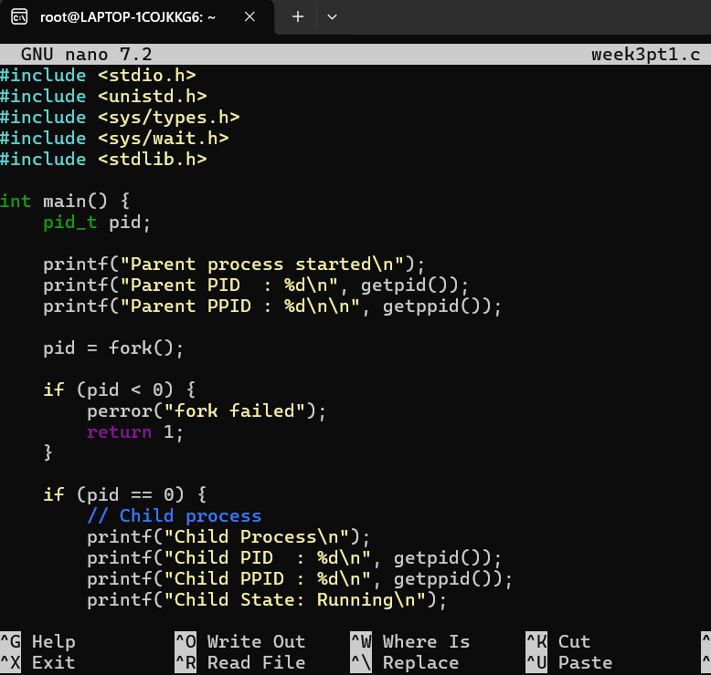
Output:
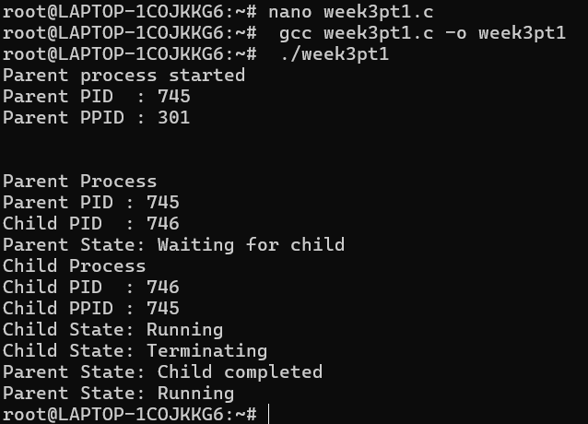
Observation: I learned how the fork() system call creates a child process from a parent process. I understood how to display and differentiate the PID and PPID of parent and child processes. I also learned how a parent process waits for the child process to complete using wait() and observed the different process states during execution.
Task2: The aim is to observe process state transitions such as Running, Waiting/Sleeping, and Terminated using Linux commands like ps, top, and /proc.
Source code:
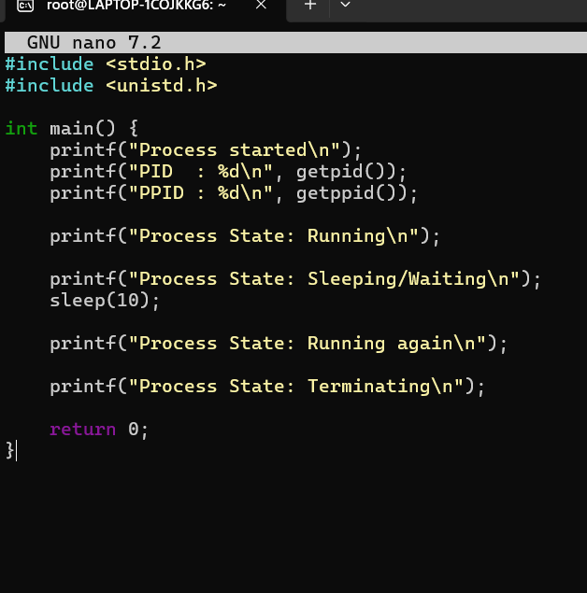
Output:
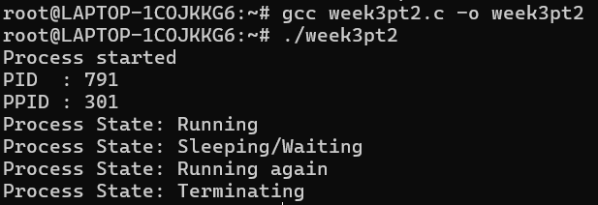
Using command top():
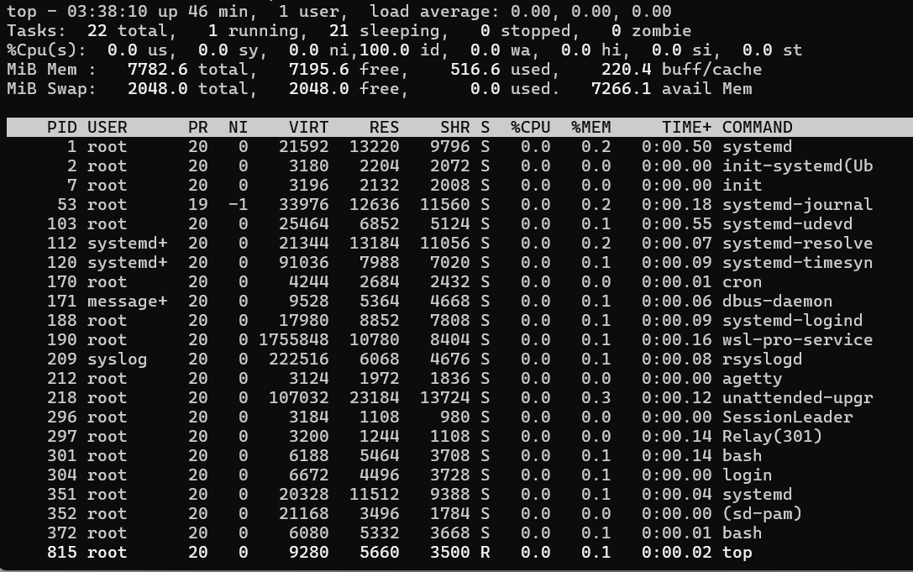
Using ps-ef command:
Observation: The process was executed and monitored using Linux process-monitoring commands. The top command was used to observe the running process, while ps was used to identify the process and its PID. The experiment showed that a process can change between Running and Sleeping/Waiting states during execution. The process finally terminates after completing its execution.

